1. ANALISIS
   1. Analisi Data
      1. Entity Class Diagram

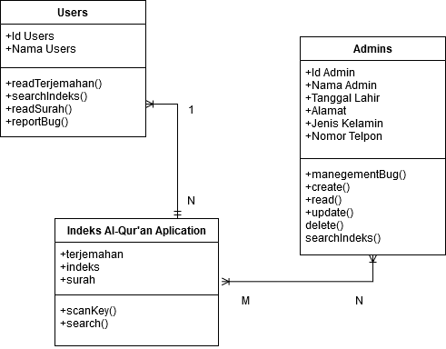

* 1. Analisis Fungsi
     1. Data Flow Diagram (DFD)
        1. Data Flow Diagram Konteks

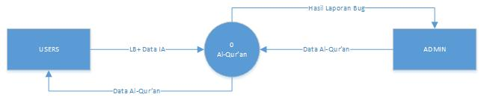

* + - 1. Data Flow Diagram Zero

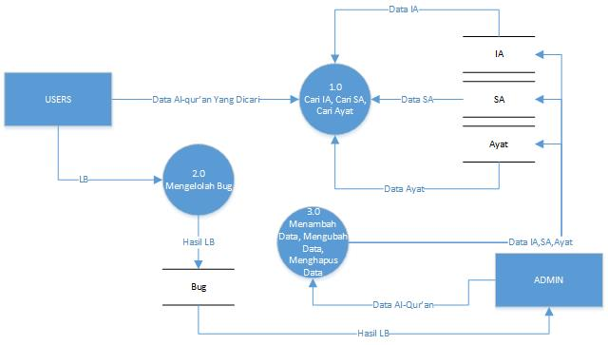

* + - 1. Data Flow Diagram Level 1 proses 1.0

**keterangan**

1. IA = Indeks Al-qur’an
2. SA = Surah Al-Qur’an
3. LB = Laporan Bug

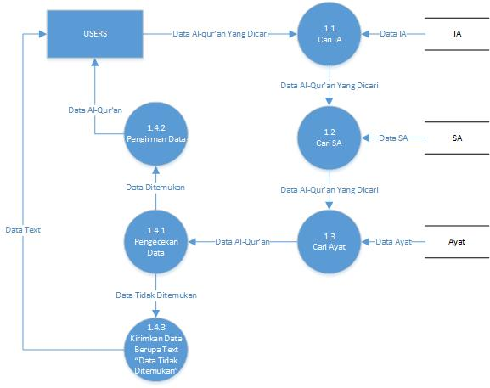

* + - 1. Data Flow Diagram Level 2 proses 1.4



* + - 1. Data flow digram level 1 proses 3.0

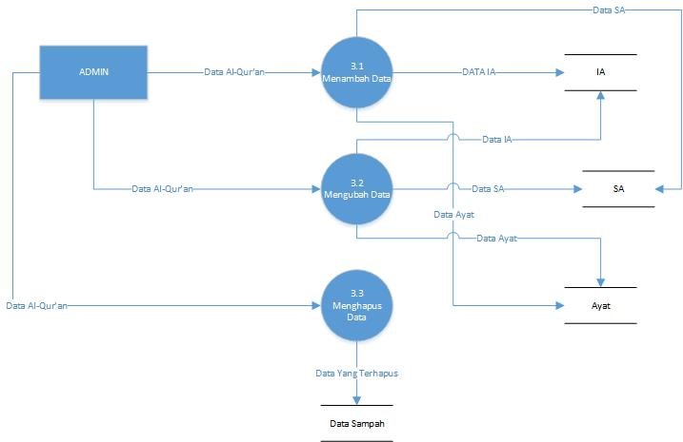

* 1. Analisis Perilaku
     1. Activity Diagram

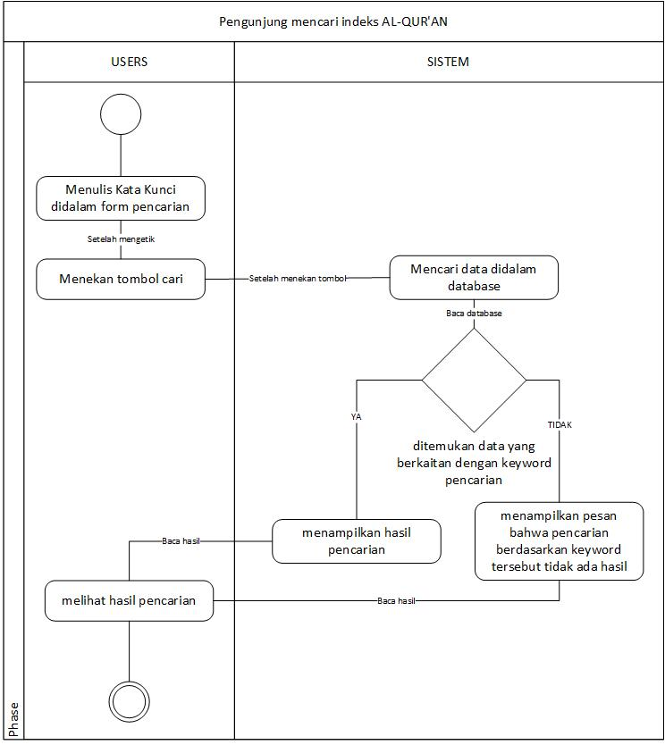

* 1. Prototype Aplikasi